Loan App

TECHNICAL DESIGN DOCUMENT

|  |  |
| --- | --- |
| **Author** | William Austin |
| **Last Updated** | 09/23/2023 6:48pm Mountain |
| **Version Number** | 1.0 |

**Version History**

| Name | Date | Reason for Change | Version |
| --- | --- | --- | --- |
| Austin, William | 09/23/2023 | Creation of Document | 1.0 |
|  |  |  |  |
|  |  |  |  |
|  |  |  |  |
|  |  |  |  |

**SECTION 1 :**

# INTRODUCTION

Purpose

Loan_App is a user-friendly and free-to-use online loan calculator designed to empower users with quick and accurate estimates of their loan payments and the total interest they'll pay over the course of their loan term. Whether you're planning to take out a mortgage, car loan, or any other type of installment loan, Loan_App is here to simplify your financial decision-making. The primary purpose of Loan_App is to provide users with a reliable tool for better understanding the financial implications of their loan choices.

Terminology

| **Name** | **Comments** |
| --- | --- |
| Angular | The primary framework used for developing the frontend of Loan_App, providing tools and libraries for building dynamic, single-page applications. |
| Component | A fundamental building block in Angular applications, encapsulating a part of the user interface and its logic. Components enable the creation of reusable UI elements. |
| Module | An organizational unit in Angular that groups related components, directives, services, and pipes. Modules help manage the application's structure and dependencies. |
| Router | The Angular router module that facilitates navigation between different views and components within the application, enabling a seamless user experience. |
| Dependency Injection | A design pattern in Angular used to manage the creation and sharing of application objects, promoting modularity and testability in the codebase. |
| Observable | A foundational concept in Angular for handling asynchronous operations, allowing for reactive programming and the management of data streams, often used when working with HTTP requests and real-time data updates |

**User Personas**

David Adams

The Financial Planner

“In my line of work, precision and

efficiency are non-negotiable. I need a loan

calculator that keeps up with my pace and

ensures my clients get the best advice

possible."

Background - David is a 40-year-old certified financial planner with a degree in finance and economics. He operates a successful financial advisory firm in the city, serving a diverse client base that includes high-net-worth individuals, families, and business owners. He has tried other loan calculators and they can’t provide all the features he wants. He wants to be able to quickly change currencies and make predictive adjustments for FED regulations.

Goals - David's primary goal is to provide expert financial guidance to his clients, ensuring they achieve their financial objectives. He prides himself on staying up-to-date with the latest financial tools and technologies to offer the best advice possible.

Challenges - With a growing client list, David is constantly on the move. He relies on software tools to streamline his work, from managing portfolios to calculating loan scenarios. He often tries to sell himself while on the golf course and wants to show how quickly something easy like a Treasury Bond could make money.

Lisa Parker

The Auto Enthusiast

"Cars are more than just machines to

me; they're a way of life. But let's

face it, dealing with auto loans isn't

the most thrilling part of the hobby. I

need a calculator that understands the

soul of a car lover."

Background - Lisa is a 35-year-old software engineer working at a cutting-edge tech startup. She has a passion for vintage cars and enjoys attending car restoration workshops in her free time. She owns three classic cars, each with a unique story. Her father raced stock cars in the country on the weekend. They often worked on the cars together in their spare time. Lisa loved her father. Once when she was a teen, her Dad brought her to the Indianapolis 500. It is one of her fondest memories. He passed away recently, and Lisa has been delving into the world of classic cars and classic car restoration in her free time. But it’s an expensive endeavor unless you’re Jay Leno or Jerry Seinfeld.

Goals - Lisa's love for cars extends beyond the driving experience. She's always on the lookout for her next project and frequently explores auto loans to fund her purchases. Lisa wants to ensure she can continue pursuing her passion without compromising her financial stability. She makes a good living, but wants to make sure adding all the various loans for different cars won’t put her in the poorhouse.

Challenges - Lisa is well-versed in programming languages but is relatively new to the intricacies of auto loans. She's looking for a loan calculator that caters to the specific needs of car enthusiasts like her.

Sarah O’Neal

The First-Time Homebuyer

"Moving to this new city was a big

step for me, and owning a place here

would be a dream come true. But

honestly, all this mortgage stuff feels

like I'm deciphering hieroglyphics. I

need a tool that makes it as simple as

ordering takeout."

Bio - Sarah is a 28-year-old marketing professional who recently relocated to a vibrant metropolitan area for a new job opportunity at a digital marketing agency. She's single and currently renting an apartment in the city. She’s always longed to have a place of her own. She’s third of renting. It feels like she’s throwing her money away. She wants to have an asset. She also doesn’t want to overextend. She’s seen friends buy homes that are out of their budgets and lose those homes just as quickly. Her family was hit hard by the 2008 housing crisis and she’s vowed that won’t be her.

Goals - Sarah sees homeownership as a milestone in her life and an opportunity to establish herself in her new city. She's been diligently saving for a down payment and is excited about the prospect of purchasing her first condo. She wants to make sure she can afford exactly what she wants. She also wants to see how various downpayment and interest rates can effect her monthly payments. She would love to see how much increasing her monthly payment would save her in interest.

Challenges - Having grown up in a family where homeownership wasn't common, and when it was it ended in disaster, Sarah feels like she's navigating uncharted waters. She often seeks advice from friends and family and relies on online resources to learn about mortgages.

**USER STORIES**

| DAVID’S STORY | STORY POINTS |
| --- | --- |
| As a Financial Planner, I want to provide precise and accurate loan calculations for various scenarios, so that I can quickly evaluate and compare loan options for my clients. | 3 |
| As a Financial Planner, I want to allow me to export loan details and calculations for my client reports, so that I can seamlessly integrate this information into my financial planning documents | 8 |
| As a Financial Planner, I want to offer a professional and customizable user interface, so that I can use it as a reliable tool in client meetings, ensuring my clients receive the highest level of service. | 13 |

| SARAH’S STORY | STORY POINTS |
| --- | --- |
| As a First-Time Homebuyer, I want to estimate my monthly mortgage payments using Loan_App, so that I can ensure they fit comfortably within my budget and make an informed decision about homeownership. | 3 |
| As a First-Time Homebuyer, I want to explain complex mortgage terms and calculations in simple language, so that I can better understand the financial implications of my mortgage choices. | 5 |
| As a First-Time Homebuyer, I want to allow me to save and compare multiple loan scenarios, so that I can explore different down payment options and loan terms to find the best fit for my situation. | 8 |

| LISA’S STORY | STORY POINTS |
| --- | --- |
| As an Auto Enthusiast, I want to provide specialized auto loan calculations, factoring in details like depreciation rates and insurance costs, so that I can make informed decisions about financing my classic car acquisitions. | 8 |
| As an Auto Enthusiast, I want to allow me to compare loan terms for different cars and financing options, so that I can choose the most cost-effective way to fund my next automotive project. | 5 |
| As an Auto Enthusiast, I want to provide an option to save my favorite loan scenarios and track my automotive investments over time, so that I can manage my car collection and its financial impact more effectively. | 3 |

2.1: Prototypes

[Functional Prototype on Canva](https://loanapp.my.canva.site/)

*(Couldn’t figure out MarvelApp for the life of me)*

Screenshots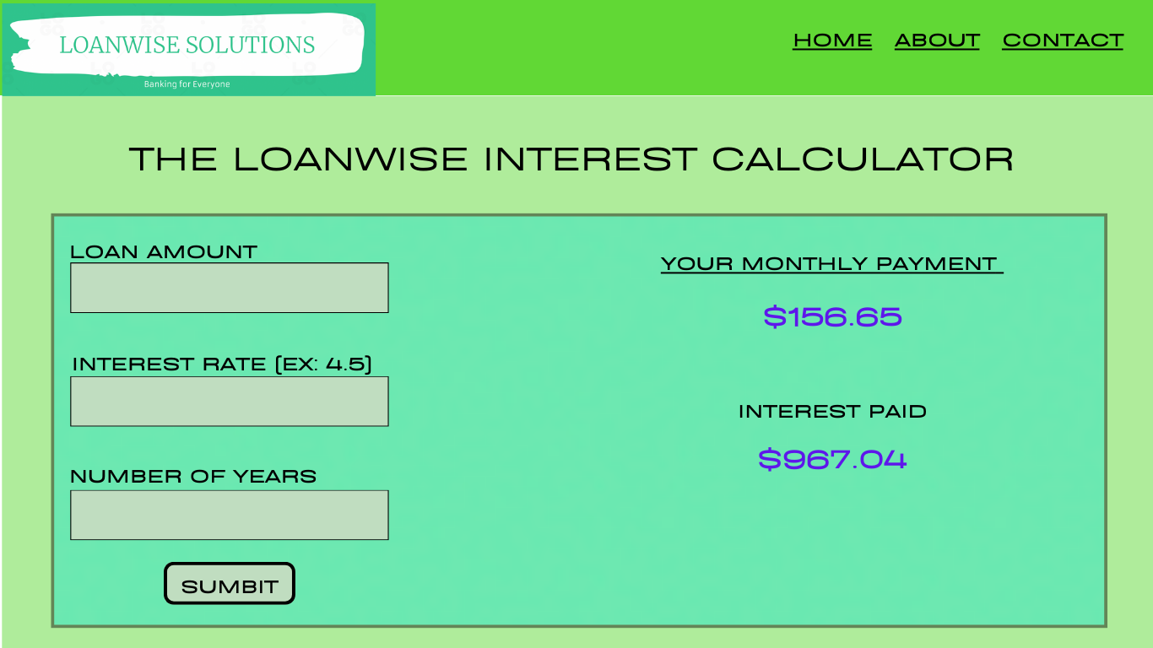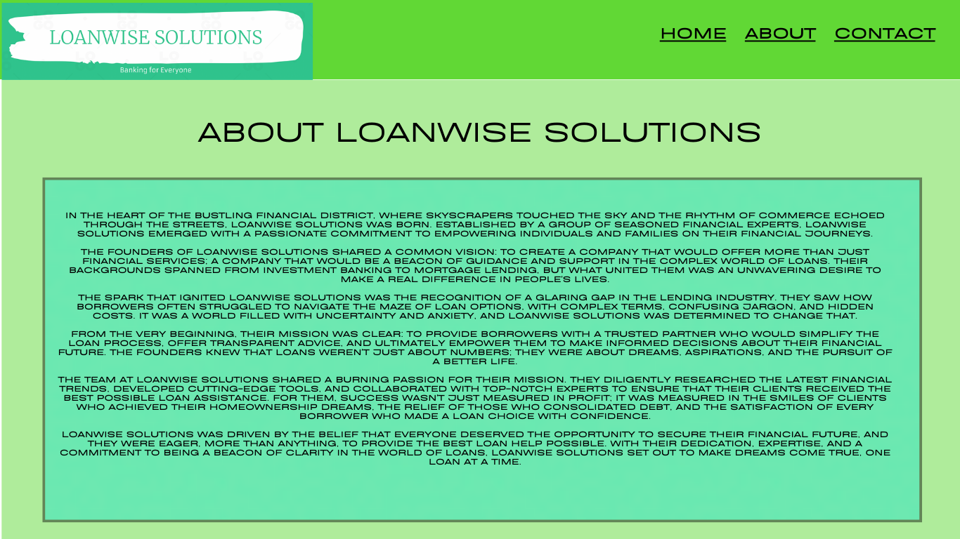

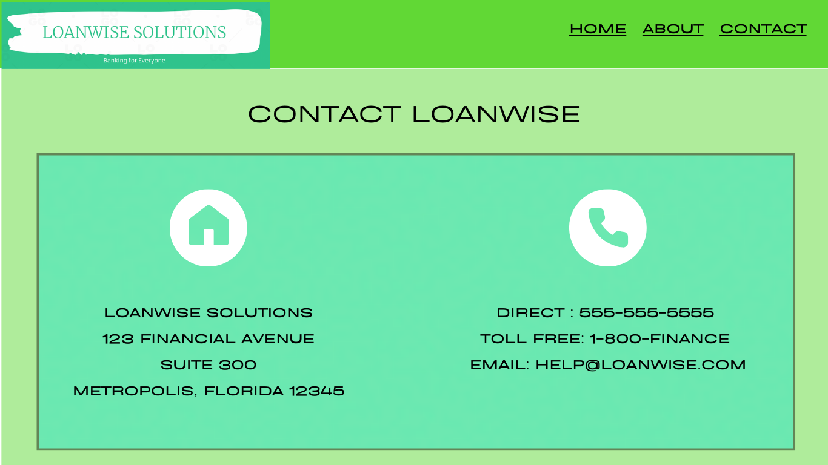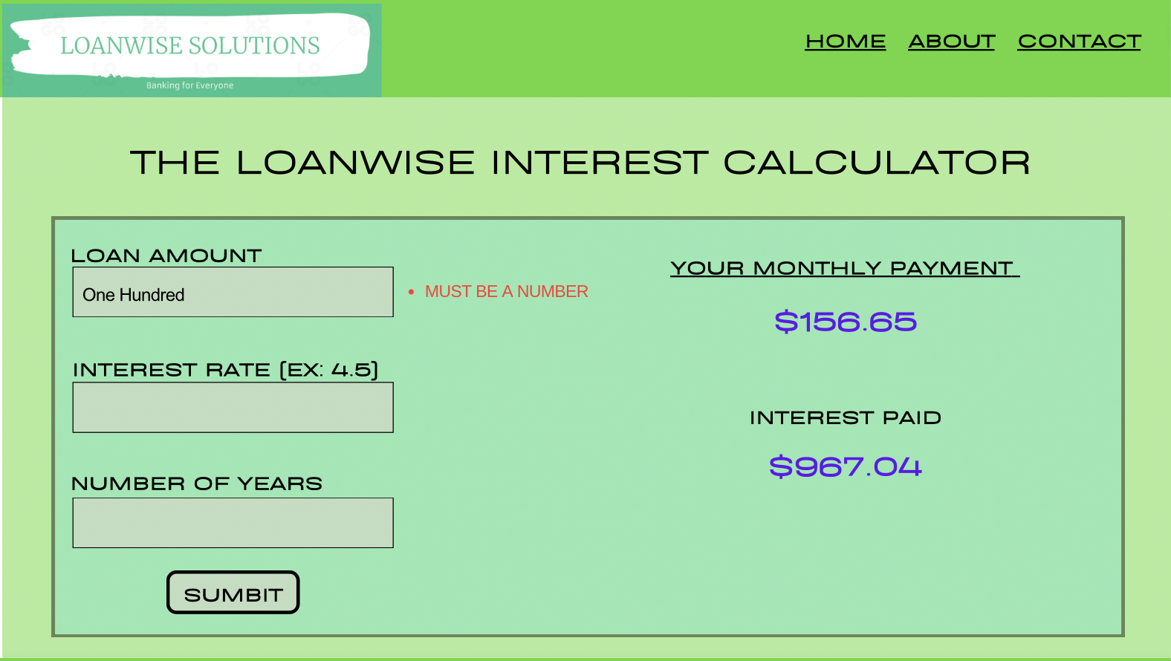

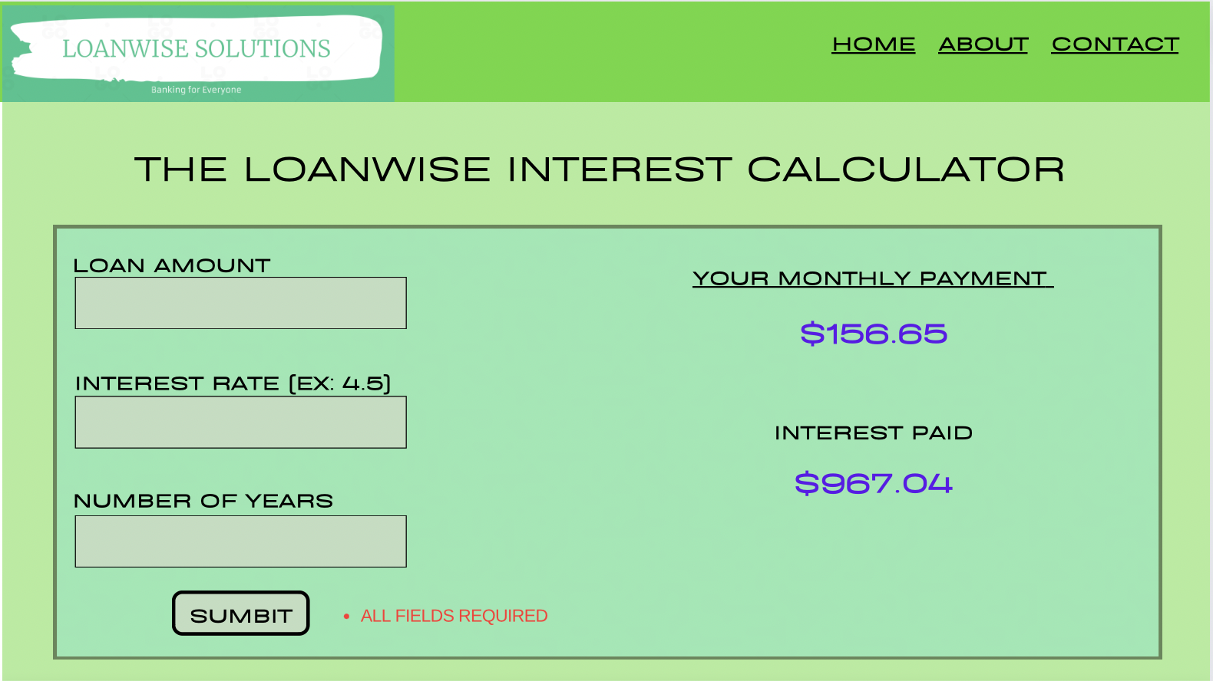

2.2: Object Relational Diagram (ORD)

*(Note - I’m not sure exactly what I’m diagraming since there isn’t any data being stored. This assumes that we create and store users and they can have many loans that they track)*

Loan_App

1

N

Customers

Loans

1

N